Game: *DIG JIM*

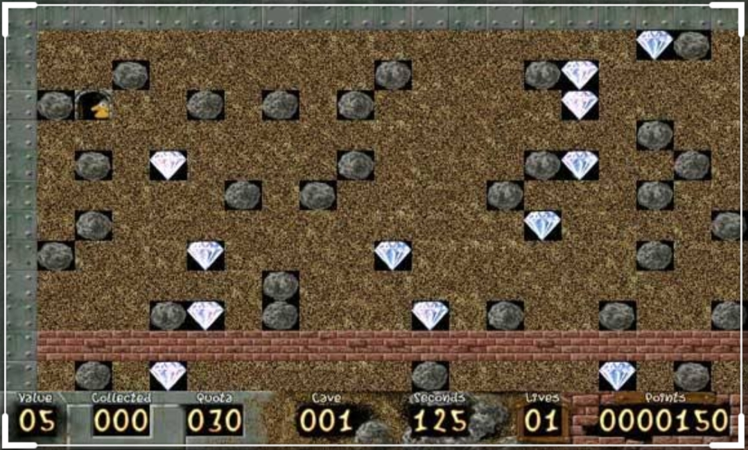
*the description:*
It is a yellow color model that works on skipping walls and digging them until it gets on the jewels that make it cross higher levels and still digging in the walls until it flattens to the house and this makes him skip those levels and go to a higher level ..
*Deliverable: *
[1] User Interface
[2] Working on collecting the largest number of jewels
[3] When collecting jewels, a higher level opened for it
[4]when the user open the board in the first once, he will see a different board in second once.. And so all.
[5]In the first level, number of jewelry and stones are less than the second level and so all "the third ,the forth ..".
*Bonus:*
1 • Sound
2 • Adding time
3 • Go to a higher level
*Input:*
Right, left, up or down from keyboard, and it eat the jewels and we add this to counter of the jewels.
*output:*
Moving to left or right or up, down according to the input and the door is opened if the number that the user count it is greater than or equal to the counter of the jewelry
If any stone fall down on it, it will lose the game.. Or appear "GAME OVER"
in the output is a score board, this board appear on it the number of jeweleries which the user "yellow object" eat them,and this board increase the number one plus one till the user win in the level or lose it.

